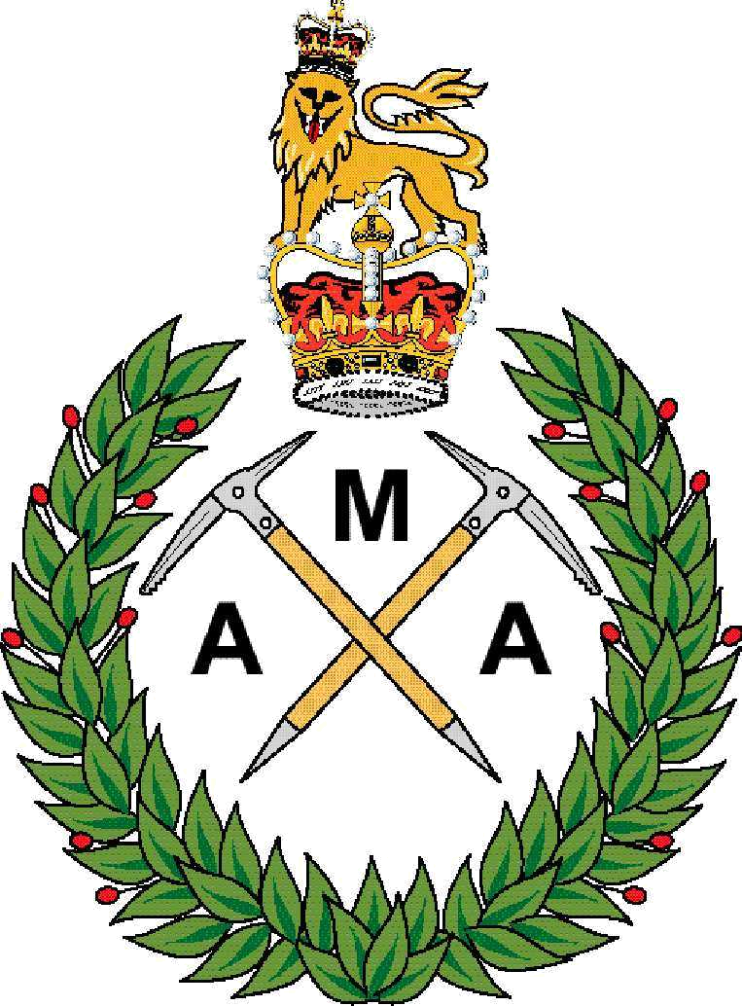

APPLICATION TO BECOME A MEMBER OF THE
ARMY MOUNTAINEERING
ASSOCIATION

ARMY

Surname:

Rank/Status:

Service Number:

Initials:

Regt/Corps:

Date of Birth:

Address (Used for Journal delivery):

Address line 1
Address line 2
Address line 3
Address line 4
Post Code

Contact Details:

Tel (Mobile):

Tel (Military):

Email 1(If serving use Personal DII address) e.g joe.brown123@mod.uk

Email 2:(Personal email address)

 WHAT IS GIFT AID?
Return Address:
For your membership request to be accepted send this form, completed, together with a completed Direct Debit form to:

The Membership Secretary

Army Mountaineering Association
JSMTC Indefatigable
Plas Llanfair
Llanfair PG
ANGLESEY
LL61 6NT

Gift Aid:
I consent for my personal details to be held on the AMA membership database and used for AMA purposes only.
Signature:

Dated:
Please tick here if you consent to Gift Aid This allows the AMA to claim an extra 28p for every £ you give as part of your membership fee. (See attached/reverse for further information on Gift Aid).

The AMA is an Associate member of the BMC. This is a recent change to our status. We no longer affiliate each individual member to the BMC due to the increasingly large cost. Members may still apply to the BMC to obtain individual membership if they believe that this is appropriate for their needs.

By ticking the Gift Aid declaration box on your membership form you will allow the Association to reclaim basic rate income tax on your annual subscription.

This will help to keep subscription levels down and still gives us sufficient funds to maintain our current excellent magazine. It will also allow us to continue supporting expeditions with significant levels of grant aid.

How do I know if I can Gift Aid my donations?
The only condition is that you are a UK tax payer.

How do I know if I am a UK tax payer?
If you have a salary, savings in a bank and/or building society, investments or a pension you may well be a tax payer, so you can Gift Aid your donations.

What do I have to do?
All you have to do is complete a simple Gift Aid declaration which confirms that we can claim back the tax on your gifts. You can do this in one of two ways:

1. Indicate on your AMA Membership Form.
2. Call the AMA Membership Secretary on Indefatigable (95581) 7964 or Civil 01248 718364.

Will this affect my tax status?
No. As a tax payer any donations you make to AMA have already had an element of tax removed from them, usually by way of income tax. What the Gift Aid scheme does is give back to us some of that tax as a boost to your gift.

Do I have to tell the taxman about my donations?

Only if you are asked to complete a self-assessment tax form by the Inland Revenue.

Notes:

1. You may cancel the declaration at any time by notifying the Association Membership Secretary. The declaration will then not apply to donations you make on or after the date of cancellation or such later date as specify.

2. You must pay an amount of income tax and/or capital gains tax at least equal to the tax that the association will reclaim on your donation in the tax year.

3. If in the future your circumstances change and you no longer pay tax on your income and capital gains equal to the tax that the Association reclaims you can cancel your declaration.

4. If you pay tax at the higher rate you can claim further tax relief in your Self Assessment tax return.

Instruction to your
Bank or Building Society
to pay Direct Debits

Originator’s Identification Number

9
0
7
5
9
3

Please fill in the whole form and send to: The Membership Secretary, Army Mountaineering Association, JSMTC Indefatigable, Plas Llanfair, Llanfair PG, Anglesey, LL61 6NT.

Name and full postal address of your Bank or Building Society Branch:

Name of Bank
Address line 1
Address line 2
Address line 3
Address line 4
Post Code

Name(s) of account holder(s) (as shown on bank card)

AMA Reference number (for office use only)

Bank Details

Sort Code:

Account Number:

Instruction to your Bank or Building Society: Please pay The Army Mountaineering Association Direct Debits from the account detailed on this instruction subject to safeguards by Direct Debit Guarantee.

Signature:

Date:

Please note: Banks and Building Societies may not accept Direct Debit instructions for some types of account.

Cut here and retain this portion for reference

Cost of Membership
At the time of printing (Oct 05) the annual subscription is £15.
If you would like to find out the latest information ring the Membership Secretary on Indefatigable (95581) 7964
or Civil 01248 718364, or email secretary@armymountaineer.org.uk

This Guarantee is offered by all Banks and Building Societies that take part in the Direct Debit Scheme. The efficiency and security of the Scheme is monitored and protected by your own Bank or Building Society. If the amounts to be paid or the payment dates change, you will be told of this in advance by at least 14 days as agreed. If an error is made by The Army Mountaineering Association or your Bank or Building Society, you are guaranteed a full and immediate refund from your branch of the amount paid. You can cancel a Direct Debit at any time by writing to your Bank or Building Society. Please also send a copy of your letter to:
The Army Mountaineering Association, Indefatigable, JSMTC, Plas Llanfair, Llanfair PG, Anglesey, LL61 6NT
This guarantee should be detached and retained by the member.

THE DIRECT DEBIT GUARANTEE

